Original Models (Artifacts):

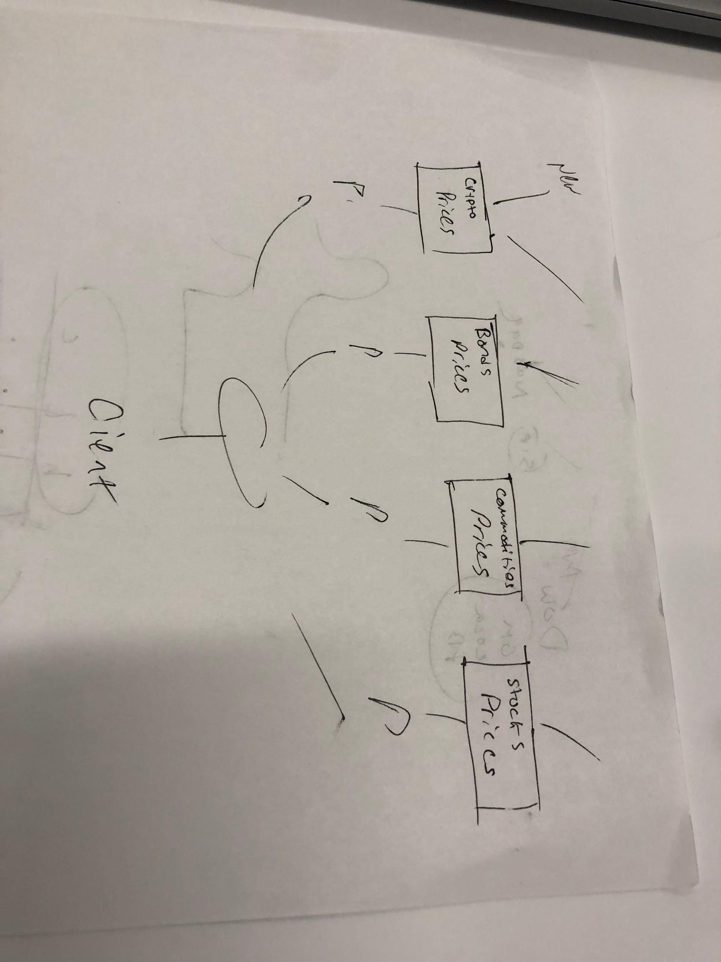

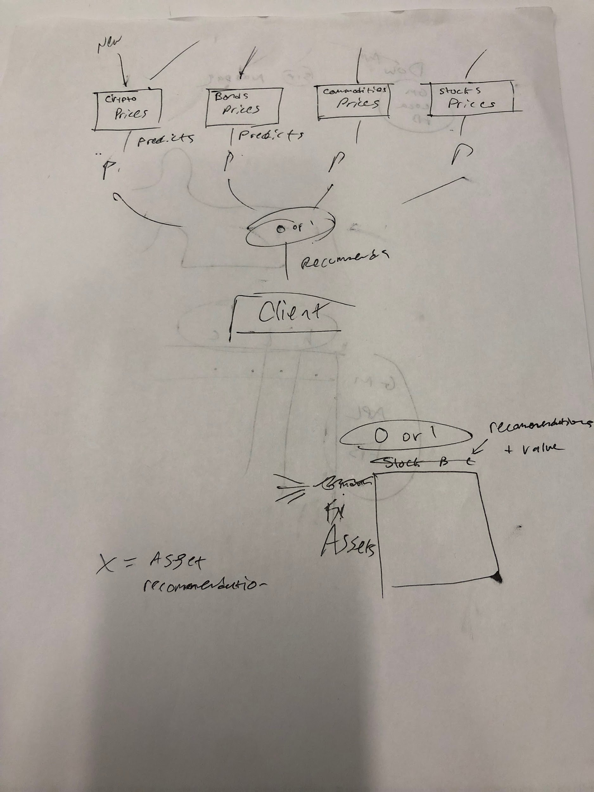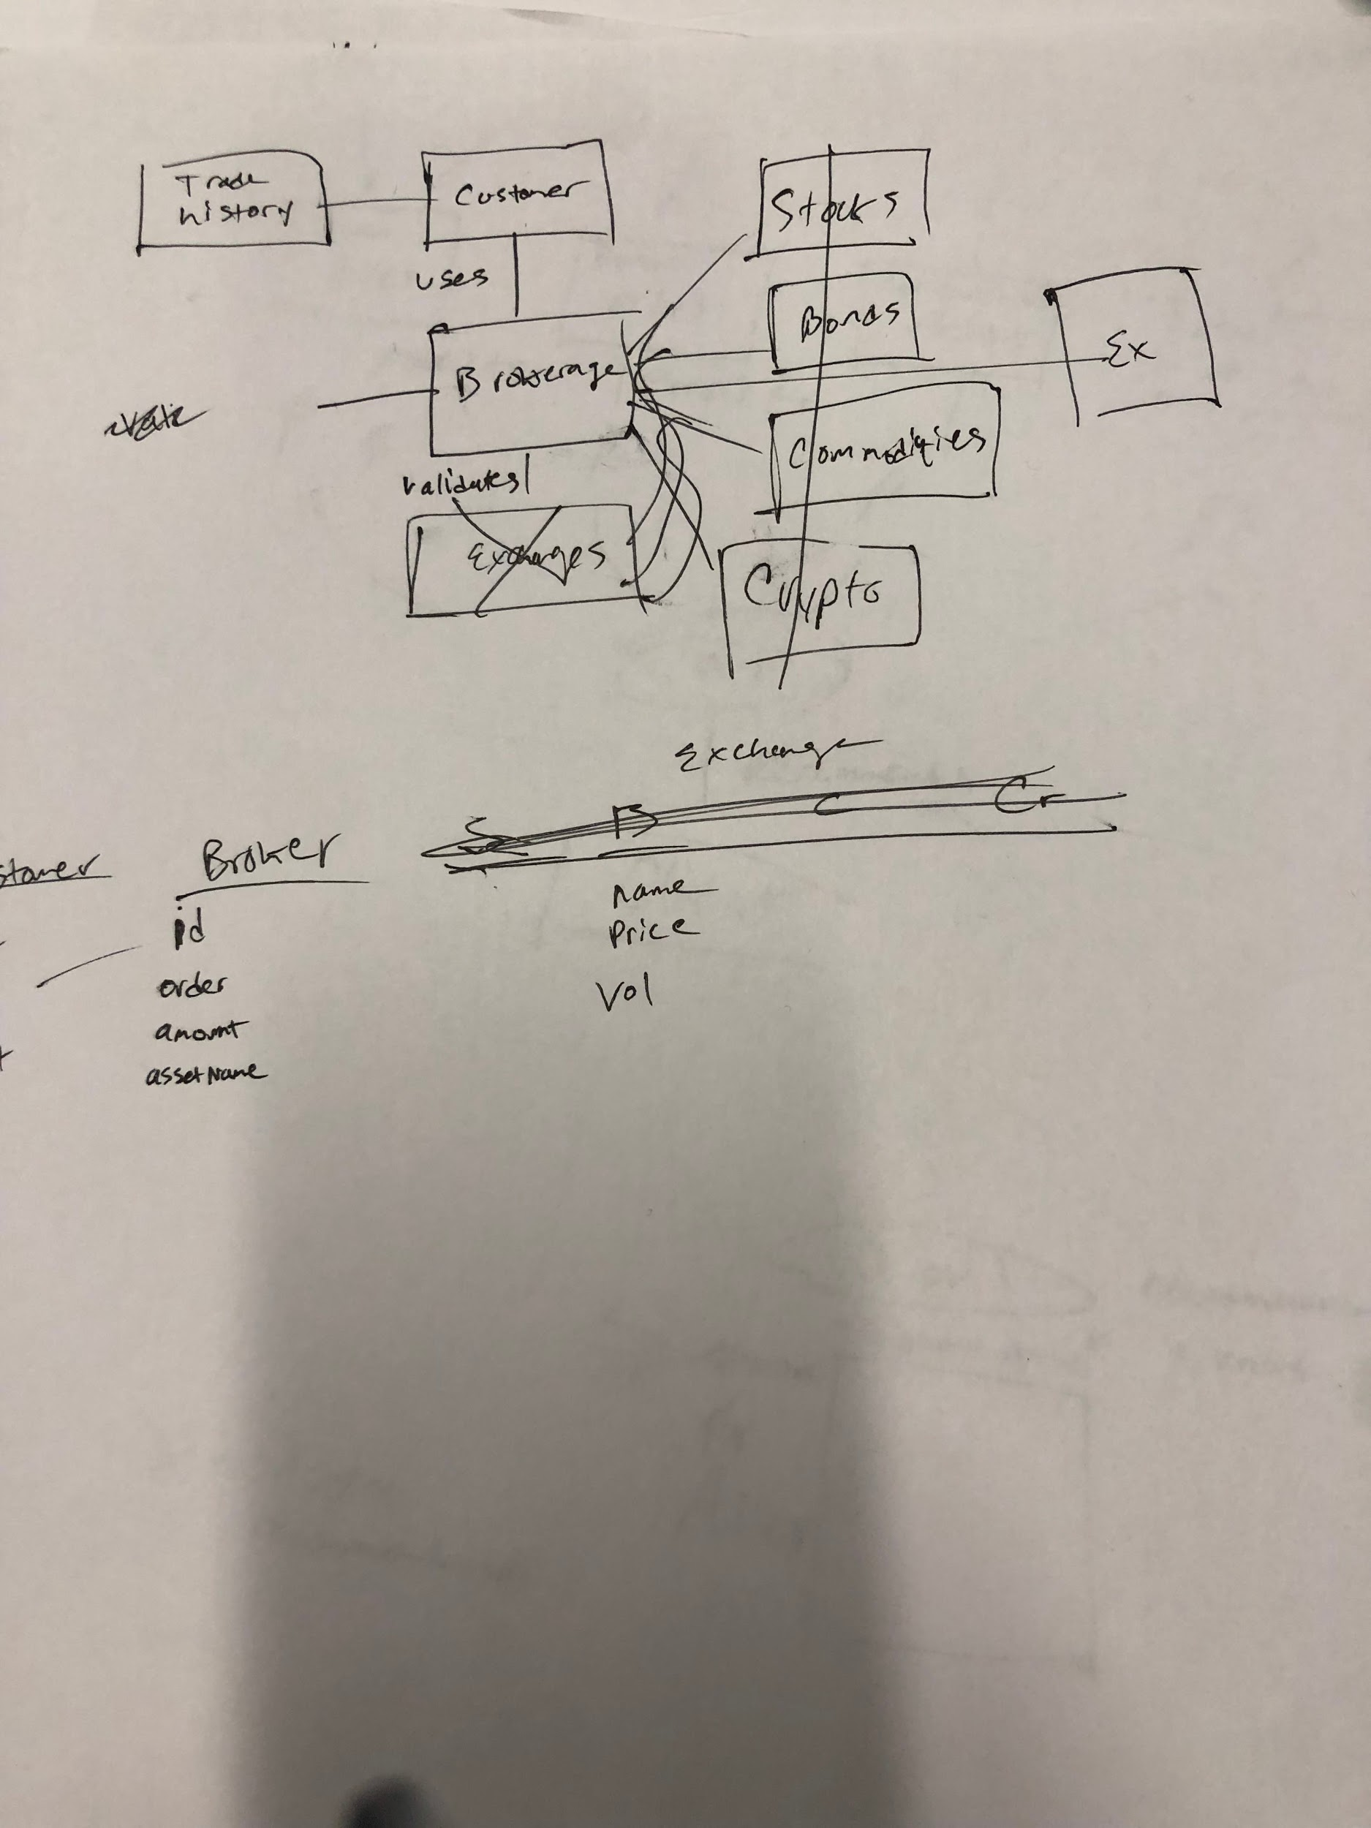

New Model:

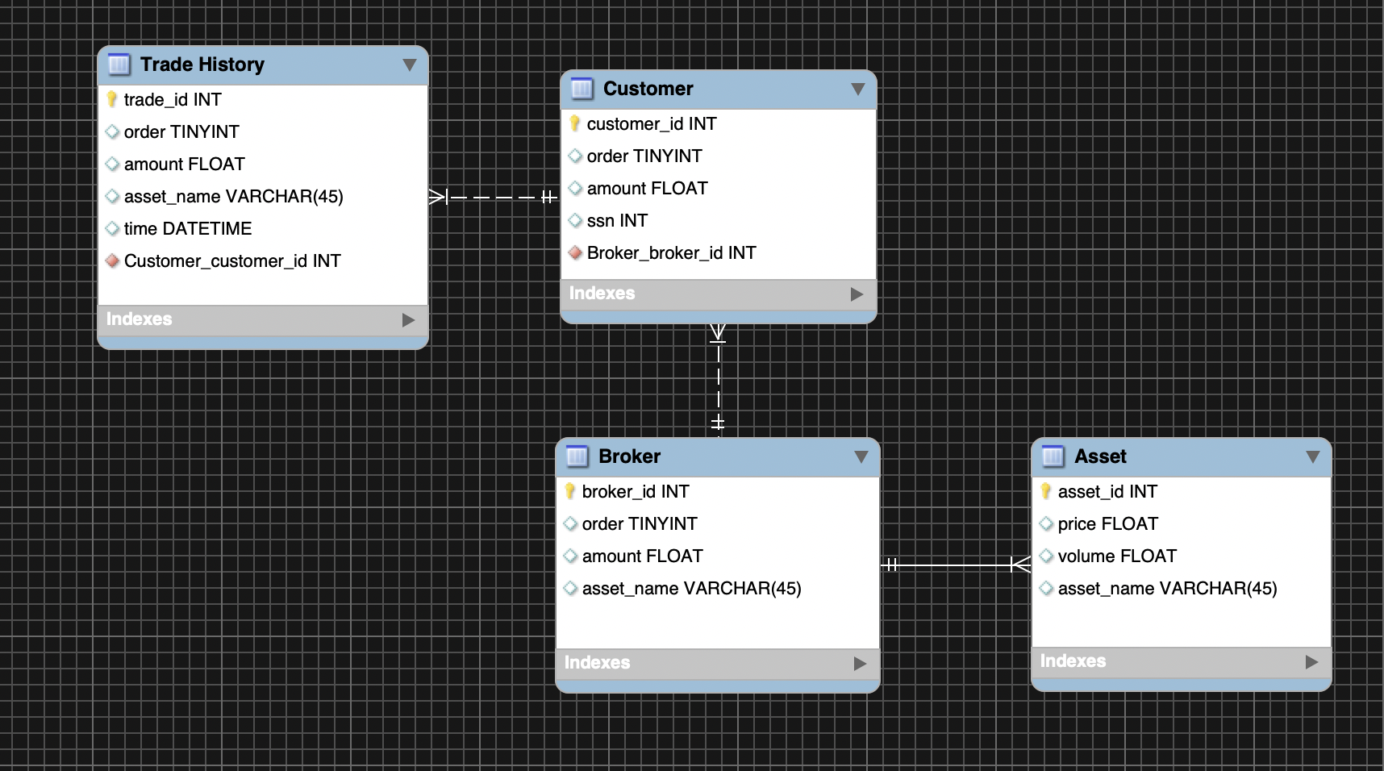

Our new model takes a more simple approach toward stocks. Rather than giving a prediction of certain outcomes, our new database will allow customers to buy stocks instead.

The start of this system begins with customers having a unique ID. In addition, there are several key details under the customer entity like their SSN and a foreign key of broker_id assigns each customer a broker. There is a 1 to n relationship between customer and trade history, with a foreign key in trade history for holding which customer the trade history is for.

There is 1 to n relationship between the broker and customers because the broker can have many customers. The broker has a unique identifier with broker_id. The broker also holds the order, amount, and asset_name that the customer is buying.

There is also a 1 to n relationship between broker and asset, with the broker having access to multiple assets to trade on behalf of the customer. The asset has a unique id and important information like volume, price, and name.

Overall we followed the following approach towards creating this ER diagram.

1. Identify the entities
2. Identify relationships
3. Describe the relationship
4. Add attributes